It is hard to believe that six months have flown by so rapidly. But there are lots to learn and do and time is just not enough for all that needs to be done.
March 2016

A lot to learn

Building a house
When we came to Bolivia, my husband brought one of his friends from Romania to help him with the starting of honey production, but the bees were not as productive as we hoped, so they found themselves with not much to do. Looking around they realized that there is a big housing need so they started on a building project.
There is no limit to the usefulness of the one who, putting self aside, makes room for the working of the Holy Spirit upon his heart, and lives a life wholly consecrated to God.-Ellen White-Southern Watchman, Aug. 1, 1905.
Not wanting to leave my man without help, I learned to mix cement, walking on air - helping to put up the roof, lift up the walls - we used plastoform walls, that is Styrofoam materials with steal studs. This system is modernly used in other countries but here it was like reinventing the wheel. It would have been nice to have someone who had already worked with this system on hand, but we were just a handful of people all on our first housing project.
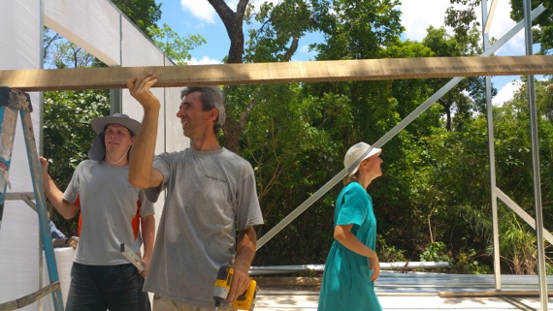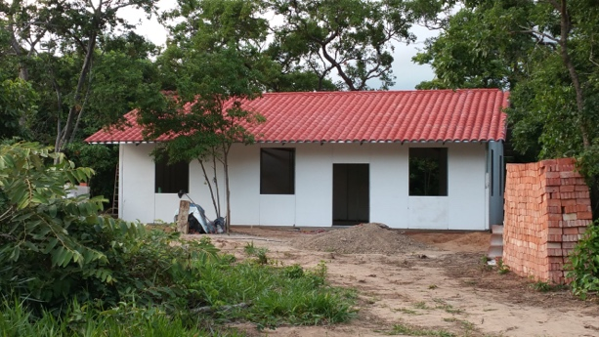
The house is sitting un-finished due to lack of funds but we have a family that is hoping to come in May and finish the house for their own use.

Brick laying
2 Corinthians 4:17 For our light affliction, which is but for a moment, worketh for us a far more exceeding [and] eternal weight of glory;
4:18 While we look not at the things which are seen, but at the things which are not seen: for the things which are seen [are] temporal; but the things which are not seen [are] eternal.

As I was talking with people about gardening here that had had the same bad experience with bugs, we were looking into different methods. Aunty Becky had built elevated beds with bricks in which to garden, so we concluded that it would be the best idea to try.

We asked local people to build them and they wanted $100 for each bed, which seem like a fortune. We wanted to build at least a couple beds. This motivated me to build my own garden beds with bricks, so I bought the materials, watched some Y-tube videos about laying bricks, and started the job. This is me working and the finished product.
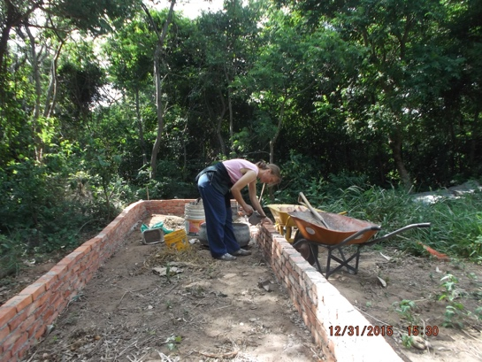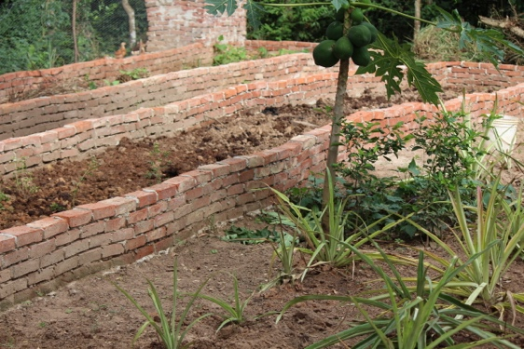

Red ADvenir inauguration

The inauguration of our media center here in Bolivia was a great event. It was our first time going on the air live and the team was not very experienced. After all, they were the ones who built the building, the sets, and made other things, but had not operated the cameras. It was a challenging Sabbath but blessed too. For us who were part of the organizational team we saw mostly defects in our handling of everything, even our lunch arrived almost two hours late. People sat around patiently enjoying visiting, but were hungry. When the food finally arrived, it was easy to see that it would not be sufficient for everyone. The church members that came with their own food brought it out to share and in the end everyone had enough. How gracious is God.
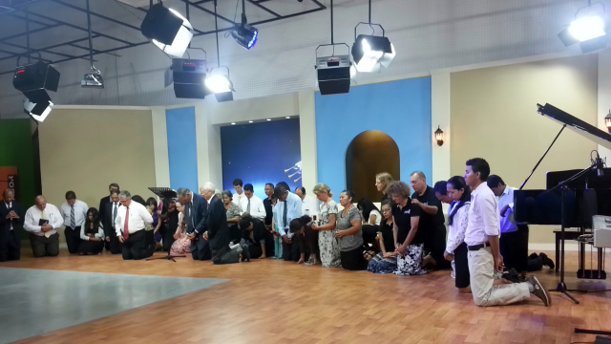

In the end all were blessed and people felt that there was a sweet spirit in the team and God made up for our mistakes. We had a nice team prayer of dedication. Truly a Sabbath to remember!
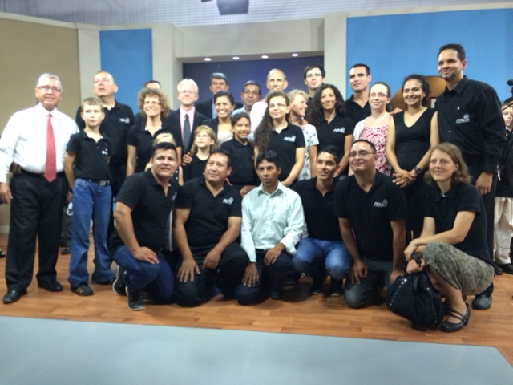
Painting
We finally got to move back to our home but the house needed painting. I said, “that is something I’ve watch people doing”, and so, with my husband’s help, I painted two rooms. I was very thankful because by Friday night the two rooms were finished and the house was in a livable and comfortable condition. We enjoyed a lovely Sabbath afternoon fellowship with our missionary team.
Unfortunately, I did not think of taking a picture while I was painting.

Health fare
The same week while I was painting we were in a 10 day health fare for our neighborhood school. We were invited to go from class to class and present the eight laws of health. This was truly a nice occasion to meet and interact with our neighbors. I thought I would be just helping in the back, but I ended up presenting the topics of air, water, trust in God, and rest - all in Spanish.
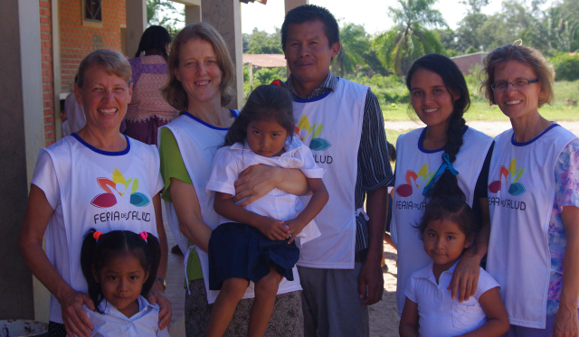
I had fun seeing how well they paid attention to this lady with a strange accent. The good part of it is that nobody laughs at you when you do not say a word correctly they just simply correct you and you continue the presentation. This is very encouraging for us extranjeros (foreigners).
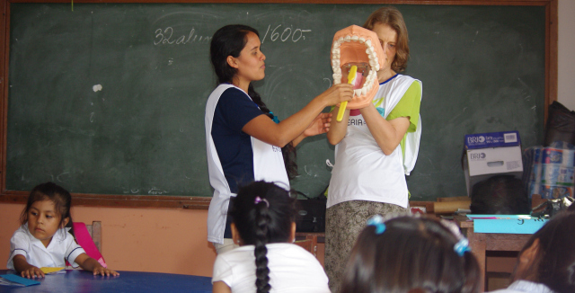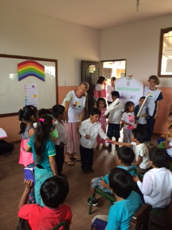
The children were very lovable, but in our opinion the schooling system here is very relaxed with the rules to the point of chaos; the rest you just imagine.
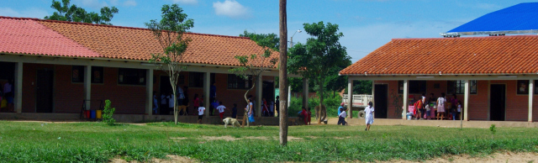
Sunday we presented a health fare in a nearby village where we usually go to church, Pedro Lorenzo. I presented water as it is my favorite part of the health fare. I learned to present this twenty years ago at Herghelia, Romania when I worked at the heath center.
At Pedro Lorenzo we had a great team. We enjoyed working together.
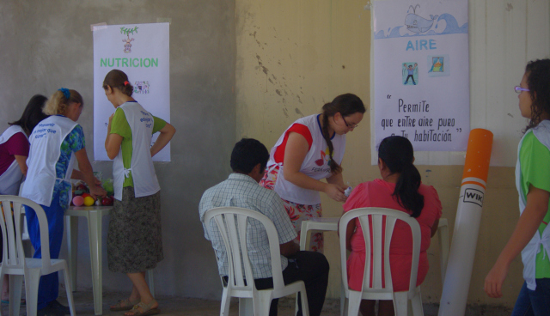
Now, we have other invitations in Santa Cruz at a public school and in the Highlands of Bolivia for a whole village.
Please pray for this project as the people in the highlands are very needy and yet so dear to my heart and I am looking forward to meeting them again.

Midwifery
I never thought midwifery would be something I would want to do but I am taking it up as a positive challenge. One missionary wants a home delivery, she’s read a lot about the subject and is determined not to deliver at the hospital unless complications develop. Aunty Becky said she would be willing to help but later found that she will be traveling to US at the time close to the delivery date. So I will have to be on my own. I prayed and actually with joy and fear I’m taking up the challenge. I am sure God put this challenge in my way to learn.
You would think that working three years in the nursery as a nurse I would know all I need to know. But the actual delivery is more then caring for the baby.
I believe God will help, after all delivering at home is not new nor an unnatural experience, it actually is the normal way of life.

Bible archeology

The study of Ron Wyatt’s Bible archeology has been a subject that interested me for a long time. Once here in Bolivia, Camron Schofield gave me his book that he coedited – Bible Truth Revealed- a study that goes on the track of Run Wyatt’s discoveries. I feel I have to act. So I am preparing a children’s presentation on the subject of Noah’s ark site discovery, Gomorrah, the Red Sea crossing, Mount Sinai, and the cross and tomb site.
This is an elaborate task and I greatly feel need. It requires a great deal of work and I am not sure how to do this all by myself. I have a great team in production that is willing to help and make this a reality.
So please pray for this project. As I move forward, I see new areas of development, it seems like I can never quite settle on how much or how exact it should be done. One idea that I have is to take the children to these sites and make the recording there. Funds would be necessary for the travel of a whole crew. So I leave it in God’s hand. It is nice to see how God will surprise us.
If you are interested in helping in this process, please pray. You may also contribute financially.
May God bless us all.

Gospel Ministries International

P.O. Box 506 Collegedale, TN 37315
Bolivia Volunteer Support or the Cristea family’s project

